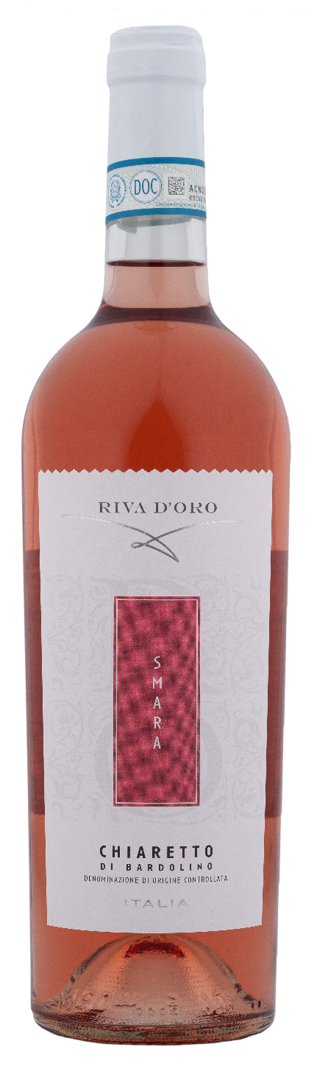
CHIARETTO DI BARDOLINO DOC – SMARA

Grape: Corvina, Rondinella and Molinara
Alc. Vol.%: 12
Vintage: 2025
Residual sugar g/l: 5,0
Total acidity g/l: 5,8
Region: Veneto
Production zone: Vineyards in the Bardolino area
Capacity: 750ml, 1500ml

CHARACTERISTICS

Vinification: Light pressing and short maceration of the skins at a controlled temperature
Aging: In steel tanks until bottling
Yield per ha: 13000kg
Colour: Vivid pink with orange reflections
Bouquet: Elegant, fresh and fruity notes
Flavour: Fresh, round and soft

SERVING SUGGESTIONS

Perfectly paired with white meat and fish dishes of all kinds.
Serving temperature 8 °C
TECHNICAL INFORMATION / PALLETIZING

Size 750ml:
Article Nr. V09014A
GTIN-13 bottle 8017868002819
GTIN-13 carton 8017868004271
Closure Cork
Bottles / carton 6 bottles
Pallet size 80x120cm
Cartons/layer 21
Cartons/pallet 105
Kg/carton 7,8
Kg/pallet 840

Size 1500ml:
Article Nr. V09015B
GTIN-13 bottle 8017868002826
GTIN-13 carton 8017868004660
Closure Screwcap
Bottles / carton 6 bottles
Pallet size 80x120cm
Cartons/layer 14
Cartons/pallet 56
Kg/carton 13,5
Kg/pallet 780

Contains sulphites
GMO Free
Revisione 01. 14.05.2026

